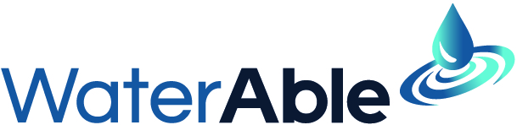

Thank you to our partners and members for your support and collaboration during 2023-24. The following are our achievements for the year under our four strategic aims.

**Collaborate with our partners to improve disability inclusion.**

* We held our third annual Day of Action workshop in May. This year we focused on reasonable adjustments and encouraged our partners to use the model policy we provided to improve their processes.
* We presented at partner events to support efforts to improve disability inclusion at Sydney Water, Seqwater and Coliban Water.
* In April we presented at OzWater in collaboration with our partner Greater Western Water on removing barriers to disability inclusion during all stages of employment.

**Amplify the voice of people with a disability across the water industry.**

* In December we held an event with guest speaker Akii Ngo to celebrate *International Day of People with Disability*. We were thrilled that The Hon Harriet Shing, Victorian Minister for Water, could join us at this event. Thank you to Melbourne Water for hosting us.
* We continued to promote WaterAble, particularly new members of our committee to demonstrate the diversity of disability in our sector. This year, we were able to bring a clear focus on neurodiversity at our workshop and through the election of our new Chairperson, Anita McKenzie.
* Through a generous donation from Coliban Water, we engaged a First Nations business to create WaterAble pins. We have distributed the pins to partner organisations and encourage members to wear them with pride.
* We were a finalist in two major disability awards – The Disability Leadership Institute Award for Innovation, and the Australian Disability Network award for employee network of the year.

**Help members with disability develop their careers.**

* The second year of our leadership program kicked off in May. We had eight people graduate from this program in September. This brings the number of graduates of the program to 12. We were particularly pleased to be able to run this program with participants from Queensland, New South Wales and across Victoria.
* We held two meetings with our members to talk about our plans and activities and gain feedback and ideas to ensure we are meeting the needs of our members.

**Evolve our organisation to ensure its sustainability and impact.**

* This year we have put a lot of effort into establishing our national framework and new operating model as a VicWater program. These changes are designed to ensure that WaterAble is sustainable into the future.
* We are thrilled that all 18 Victorian water corporations are now formal partners of WaterAble. We have also partnered with one water corporation in New South Wales, two in Queensland and a national private sector organisation.
* Our membership has expanded to around 100 people.

